Exploratory Data Analysis
Figure ***#of the appendix shows the best for arsenic of its variable filtered for Aquifer group 1***. The wells that were above the Canadian drinking water standards were turbid, even more so than those of sea water intrusion. However, the well samples did not have much chloride or specific conductance. Those samples all had high alkalinity (>150 mg/L)*** but did not exhibit high levels of chloride, sulfate, or nitrogen. The graphs for power BI show no specific pattern and incomplete data therefore as a result the metal was discontinued for further analysis.
Manganese over the Canadian water drinking standards of *** against other factors are shown in appendix figure***. In aquifer group 1, manganese levels all had high iron levels, low phosphorus levels and high levels of water hardness. Said levels also had moderate specific conductance, but not at the cut off for seawater intrusion and low turbidity.
In addition, Lead above the Canadian drinking water standard of **** against all other factors from aquifer group 1 are shown in appendix figure ***** and follow a similar pattern to manganese. Low specific conductance, low turbidity and very low chloride levels were apparent patterns along with higher lead concentrations to a limited extent being hard. Meanwhile uranium had few levels above the Canadian water drinking standards of ***** (Figure ***, Appendix). However, an apparent pattern was shown when it came to, rising concentrations with rising specific conductance, hardness, calcium, dissolved sulfate, alkalinity, PH, and turbidity.
The line graphs of aquifer Group One [figure*** appendix] shows a downward trend of iron. Nonetheless it is difficult to tell if there is a yearly trend or if it's based on sampling frequency and distance. lead goes down slightly as does arsenic, while there is a spike in uranium. Although uranium could be due to growing interest in testing. Furthermore, seasonality is difficult to determine given that samples were taken in different places. However specific conductance, turbidity and chloride show somewhat of a potential distinct seasonality pattern. In addition to the above analysis for saltwater intrusion, there is not enough data to make numerous or if any conclusions.
Fig. *** (Appendix) Shows the different metals along with their Canadian water drinking standard limit against precipitation for Aquifer group 1, Cd, Pb, As. Which all were low precipitation predominantly the ones above CWD standards. Mn above the drinking water standards was slightly related to low concentrations. Furthermore, higher specific conductance, turbidity and chloride above the saltwater intrusion cut off was showing to be related to low precipitation. Hardness related slightly to low precipitation and higher nitrogen, sulfate and alkalinity also had lower precipitation levels. Meanwhile Fe tended to slightly increase with higher precipitation.
The climatology monthly precipitation values were subtracted from precipitation to get the difference between the actual and predicted values (‘FD’). Values above Zero were taken to be flooding conditions, while values below 0 were taken to be drought conditions. For Aquifer group 1, no pattern was observed for alkalinity, calcium, sulfate, Fe, PH, P and hardness. Considering most of the above were associated with low precipitation values. This could indicate that the well is in an already dry area or wet area when it came to Fe. Uranium especially over the drinking water standard, demonstrated aslight relationship with drought conditions. Meanwhile nitrogen, Cd over CWDS limits, Mn over CWDS limits and Alkalinity indicated a slightly lower relationship.

The difference between precipitation and simulated precipitations was used to represent an indication of flooding/droughts. This plotted against all metals of interest with the CWDS limit and all other potential factors for group 1, with No pattern for alkalinity, Ca, sulfate, Fe, P or Hardness. Drought conditions seemed to be related to U, especially that over the CWDS. Flooding conditions more associated with nitrogen, Cd over drinking water standards, Mn over drinking water standard earths, turbidity and surprisingly chloride. Arsenic slightly over drinking water standards were related to flooding conditions as well ??.
Minimum temperature (Fig ****) Aquifer group 1 was associated with increasing alkalinity, nitrogen, potassium, chloride and specific conductance that were over the seawater intrusion cut off and Cd, Pb, and As. Mn above the Canadian water drinking water standards was as well associated with increasing minimum temperature. The difference between the minimum temperature and the stimulated minimum temperature, (Fig ***) was plotted against the four medals of interest and all other factors. Higher temperature differences seem to be related to an increase of Lead and manganese, above their Canadian drinking water standard limits. Meanwhile Canyon? and arsenic seem to be related to lower temperature differences. While iron and chloride above the saltwater intrusion cut off increased with the higher temperature differences.
Maximum average monthly temperature for Aquifer group 1 was graft against all other factors [fig dot appendix***]. Turbidity, nitrogen, iron, and uranium increased with the maximum temperature. Meanwhile the difference between average maximum temperature and stimulated maximum temperature showed an increase of Cd over CWDS maximum standards, with chlorine and turbidity over saltwater intrusion cut offs and a slight increase in turbidity.
The line time frames indicated that there is a significant influence of geography as indicated by the variation of climatology, stimulated values and seasonality in all temperature and precipitation factors that were apparent.

Aquifer group 2 consisted around 330 data samples. Line and seasonality graphs of the data variables indicated significant sampling errors with calcium, alkalinity, and hardness (Fig. *** Appendix). Sulfate, specific conductance, and dissolve chloride indicated significant seasonality. The rest was difficult to tell between an actual seasonal pattern verse sampling and distant effects. H? and specific conductance indicated a slight decrease throughout time however TDs and sulfate involved a noticeable increase.
Uranium for aquifer group 2 [fig. Appendix*** ] did not have any concentrations above the Canadian water drinking standard. However, a similar but smaller trend observed in Aquifer group 1 was observed. Lead concentrations above the Canadian drinking water standards for group 2 was to a limited extent related to alkalinity, while other factors contained no supporting patterns. Manganese samples that were over the Canadian water drinking standard had high alkalinity, low phosphorus, high potassium, and high hardness. Arsenic above the Canadian water drinking standard against all other variables for group aquifer 2 had high turbidity and no other indication of patterns.
Precipitation for aquifer group 2 was graphed against all factors (Appendix Fig ***). Cd, Pb, As, and as shown above, CWDS and chloride, turbidity, and specific conductance above saltwater intrusion cutups? were associated with lower precipitation. Manganese above the Canadian water drinking standard cut off was slightly associated with lower precipitation. Furthermore, the differences between actual monthly precipitation and stimulated monthly precipitation was then compared to all other factors to stimulate flood drought conditions. Drought like conditions were related to lead and arsenic above the Canadian water drinking standards. As well as flood like conditions were related to P and arsenic below the Canadian water drinking standards.
Minimum monthly mean temperature for aquifer group 2 was graphed against all other factors [fig.*** appendix]. This showed a related increase in chlorides, As, Cd and Mn over CDWS limits. The difference between minimum temperature and predicted minimum temperature showed an increase of chloride and specific conductance over the water intrusion cut off limit and As, Mn over CDWS limits. Uranium and sulfate also increased with minimum temperature difference. Maximum monthly mean temperature had similar patterns to the minimum monthly mean temperature. Additionally, the differences between mean maximum monthly temperatures and stimulated maximum monthly temperatures plotted against all other factors showed an increase of chloride and specific conductance over the saltwater intrusion limit, slight turbidity and Cd over the Canadian water drinking standard slim maximum.
Chloride, uranium, and As over CDWS limits increased overtime For Aquifer group 2 with all factors showing significant seasonality along with indications of the impact of geography.
Aquifer group 3 had about 300 samples. Furthermore, arsenic above the Canadian water drinking standard against all other factors [appendix***] showed height of turbidity low with specific conductance call my? and low chloride. Cadmium had no patterns again.
Manganese above the Canadian water drinking standards [appendix fig .*** ] for group 3 showed high alkalinity, calcium, iron, potassium and hardness, following a similar concentration pattern to aquifer group 1. It as well showed lower specific conductance and turbidity. Meanwhile lead samples above the Canadian water drinking standards for group 3 [appendix big. ***] were mostly alkaline while the specific conductivity followed a similar pattern to manganese. Uranium did not have r many values above the Canadian water drinking standard. However, a smaller similar pattern for Aquifer group 3 was observed to Aquifer group 1.
Line graphs indicate a lot of sampling errors as in Aquifer group 2 [Fig *** Appendix]. Chloride and specific conductance had a noticeable increase and also variations that suggested potential seasonality.
Monthly precipitation was plotted against all other values for Aquifer group 3 [fig.*** appendix]. N, Cd, and pH increased with increasing precipitation, while As, U and Fe increased with decreasing precipitation. Furthermore, the differences between stimulated and actual monthly precipitation were also plotted against all other values. Flooding showed a similar pattern in Aquifer for group 1. Meanwhile droughts showed an increase for Ca, specific conductance over the saltwater intrusion cut off, and Mn, As above are CDWS limits.
Minimum mean monthly temperature was plotted against all other factors for Aquifer for group 3 [appendix fig .*** ]. A decrease in alkalinity, CA, K, P, hardness, U, and As was showing. Meanwhile sulfates, Cd, Mn and Pb showed an increase. While the differences between the actual and stimulated minimum mean monthly temperatures plotted against all other factors showed an increase in Cd and a decrease in Fe. Maximum mean monthly temperature showed similar patterns to minimum mean monthly temperature. As did the difference between actual and stimulated maximum monthly temperatures.
The line timelines should increase in the difference between the minimum temperature and the stimulated min minimum temperature and that all graphs showed significant seasonality.

Descriptive and Summary Statistics
###Should I have used one hot encoding?
Given that most values are scaled to be centered around zero and the smallest, this means the coefficients of variance is quite large (Tab. **** Appendix). Variance and standard deviation were also fairly large, which indicated that there is a large spread of data. This is expected due to certain wells being over the contamination standards, while others are not due to groundwater chemistry in different geology and other factors.
The bar graph of aquifer samples (Fig *** Appendix) indicate that primarily aquifer sampling was concentrated in aquifer group 1, with occasionally being concentrated in aquifer group 2. Box plots (Fig *** Appendix) Demonstrate that for CD, Pb, U, and Mn there is a large variation for aquifer groups two and three. a moderate amount of variation was showing for arsenic in aquifer groups 1, 2, and 3 and for manganese in aquifer group one. Uranium, lead and cadmium were usually fairly low but had a lot of extreme outliers indicating potential well contamination.
Pearson, Kendall and Spearman correlations matrices were calculated for the entire dataset, drought dataset, flood dataset, rising minimum temperature dataset, rising maximum temperature dataset and seawater intrusion dataset. Pearson and Kendall correlations were focused on as the first represents linear correlations and the second is similar to spearman's representing nonparametric correlations but considered to be more stringent***. the full Kendall's correlation for the entire data set is is showing in the appendix (Appendix Table***). Matrices did not take aquifer types into account and thus this may be an area for further study.
Table *** displays both the kendalls rank Correlation and Pearson correlation for the entire data set, flood data set and drought data set with a cut off of P >= 0.5. Heavy Metals of Interest and nitrogen As it has been extensively studied in these types of conditions were looked at. Both Arsenic and nitrogen showed no significant correlation To any variables In all three data sets. this does go against some previous studies ****. arsenic may also be due to lack of consistent sampling methods. Manganese had a weak relationship to iron in the normal data set which remained somewhat consistent in the flooded data set but deteriorated in drought conditions. Lead Had an extremely strong linear correlation with cadmium and a moderately nonparametric correlation with cadmium as well. Both these correlative relationships Weekend in droughts. in floods however, the linear correlation decrease but the parametric relationship remained somewhat consistent. this combination is usually anthropogenic and means and probably influenced linearly by geochemistry ****. Uranium had a weak relationship with hardness and calcium that deteriorated in flood conditions and further deteriorated in drought conditions. These relationship were likely more linear due to the lower kendals values

Table 1: Pearson (cutoff p ≥ 0.5) and Kendall rank correlations for each element of interest (As, Mn, Pb, U) and N for the entire dataset, flood dataset and drought dataset.
Element of Interest | Related Element | Normal |  | Flood |  | Drought
Element of Interest | Related Element | Pearson | Kendall | Pearson | Kendall | Pearson | Kendall
As | - | - | - | - | - | - | -
Mn | Fe | 0.5168 | 0.4111 | 0.5175 | 0.4092 | - | -
N | - | - | - | - | - | - | -
Pb | Cd | 0.9534 | 0.5630 | 0.7089 | 0.5768 | 0.6691 | 0.4870
U | Ca | 0.5670 | 0.3620 | 0.4978 | - | - | -
 | Hardness | 0.5610 | 0.3977 | - | - | - | -

The correlations from minimum temperature rise and maximum temperature rise data sets for as, MN, n, PB, and U are showing in Table ****. Arsenic and nitrogen had no correlations. the weak correlation between manganese and iron deteriorated with both Rising minimum and maximum temperatures. this again might be due to lack of data or it may indicate different Rock geochemical processes. further research might want to explore this relationship in depth over other areas and data sets. likewise the weak relationship between uranium and calcium or hardness. deteriorated so that there's no correlation in both Rising minimum and maximum temperature day data sets. both the linear and parametric correlation between lead and cadmium deteriorated to to similar values of that of drought both minimum and maximum temperature rise.
Table 2: Pearson (cutoff p ≥ 0.5) and Kendall rank correlations for each element of interest (As, Mn, Pb, U) and N for the entire dataset, dataset with rising minimum temperatures and dataset with rising maximum temperatures.
Element of Interest | Related Element | Normal |  | Minimum Temperature Rise |  | Maximum Temperature Rise
Element of Interest | Related Element | Pearson | Kendal | Pearson | Kendal | Pearson | Kendal
As | - | - | - | - | - | - | -
Mn | Fe | 0.5168 | 0.4111 | - | - | - | -
N | - | - | - | - | - | - | -
Pb | Cd | 0.9534 | 0.5630 | 0.6692 | 0.4870 | 0.6566 | 0.4816
U | Ca | 0.5670 | 0.3620 | - | - | - | -
 | Hardness | 0.5610 | 0.3977 | - | - | - | -

Kendalls and Pearson correlation for normal and seawater intrusion data sets for as, MN, N, Pb and U are showing in Table *** . Arsenic and nitrogen have no correlations. Lead’s Hadium correlation with cadmium drops to a still somewhat strong linear correlation but a parametric correlation similar to that of droughts in the saltwater intrusion data set. Saltwater intrusion data set also had a both week perimetric and linear correlations to iron. this might be due to the additional charge that seawater intrusion and corrosive weathering that seawater intrusion brings. negative week linear and parametric correlations we're also showing for uranium in seawater intruded well data sets. this might be due to location or sampling biases.
Correlation between uranium and calcium disappear in the saltwater intrusion data set. instead week negative linear correlations between chloride were showing. This Relationship was solely linear as the kendalls correlation was lower than expected. A weak Negative relationship between lead and uranium also we're showing in the saltwater intrusion data set May have also had a parametric or additional complexities due to the similarity in Kendall scores. The relationship between And calcium uranium and calcium in the main dataset seem to be replaced by a similar relationship between uranium and potassium. hardness remained nearly unchanged. However alkalinity showed a somewhat higher weak correlation in saltwater intrusion.
Table 3: Pearson (cutoff p ≥ 0.5) and Kendall rank correlations for each element of interest (As, Mn, Pb, U) and N for the entire dataset, and with noticeable sea water intrusion.
Element of Interest | Related Element | Normal |  | Sea Water Intrusion
Element of Interest | Related Element | Pearson | Kendal | Pearson | Kendal
As | - | - | - | - | -
Mn | Fe | 0.5168 | 0.4111 | - | -
N | - | - | - | - | -
Pb | Cd | .9534 | .5630 | 0.7810 | 0.4870
Pb | Fe | - | - | 0.5940 | 0.4338
Pb | U | - | - | -0.5228 | -0.4382
U | Ca | .5670 | .3620 | - | -
U | Cl | - | - | -0.5538 | -0.3452
U | Pb | - | - | -0.5128 | -0.4382
U | K | - | - | 0.5514 | 0.3521
U | Hardness | 0.5610 | 0.3977 | 0.5536 | 0.3399
U | Alkalinity | - | - | 0.6212 | 0.3873

Table *** shows the metals of interest that are above the limits set by the Canadian drinking water standard guidelines in addition to saltwater intrusion factors above the respective cutoffs. Uranium above cut-offs is scarce mainly as testing for it seem to be more recent and this might also be the reason why most of it is associated with Rising temperatures and droughts. Sonic above limits seems to have no clear pattern as it occurs in both flood and drought along with Rising minimum and maximum temperatures. this might be due to increased anthropogenic means in combination with pure climate change effects. Lead above cut off was found in 289 samples. datasets that had higher minimum or maximum temperatures than expected often had a higher proportion of lead above its limits. manganese had the most samples above recommended guidelines of 344. most of those data points occurred in droughts, Rising minimum temperatures and, Rising maximum temperatures. Sea Water intrusion factors had a higher in occurrence in drought, Rising minimum temperatures and Rising maximum temperatures. this makes sense as those increase Demand on vulnerable aquifers and thus lead to over pumping.
Table 4: Metals of interest that are above the limits set by the Canadian Drinking Water guidelines in addition to saltwater intrusion factors above their respective cutoffs for the full, drought, flood, rising minimum temperature, and rising maximum temperature datasets
 | As Above Limit | Pb Above Limit | Mn Above Limit | U Above Limit | Specific Conductance over cutoff | Residue Filterable 1.0u over cutoff | Chloride over cutoff | Total Data Points
Full Dataset | 81 | 289 | 344 | 6 | 107 | 79 | 52 | 1147
Drought Dataset | 37 | 138 | 162 | 4 | 69 | 49 | 29 | 530
Flood Dataset | 31 | 124 | 135 | 1 | 32 | 22 | 18 | 455
Dataset with Minimum Temperature Rise | 46 | 170 | 208 | 3 | 75 | 52 | 38 | 713
Dataset with Maximum Temperature Rise | 38 | 151 | 190 | 4 | 66 | 44 | 31 | 611

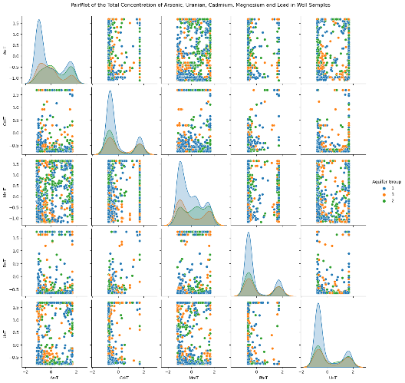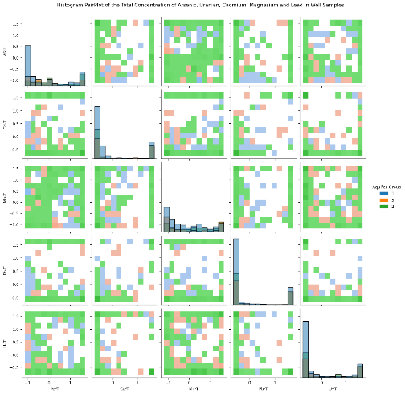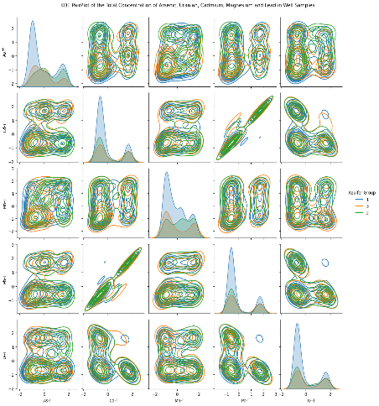
B)
C)
A)

Figure 2: A) From Left to right: A) pairplot, B) hisplot and C) KDE plots of the relationship between metals of interest for the full dataset.
Figure 1 shows the pair plot, histogram, and kernel density estimator (KDE)All the metals of Interest. Uranium's relationship with cadmium is seen on both the pair plot and KDE. Agonies and arsenic agonies and arsenic show no apparent pattern. Well a slight relationship between cadmium and Lead is observed in the KDE plot and his plots along with manganese and cadmium.
Relationships of precipitation factors, and other variables seem to display similar relationships to that showing with the correlation plots (Fig ***, ***, ***, ** appendix). there doesn't seem to be much Stand Out differences between the drought , flood, maximum temperature, or Rising minimum temperature in comparison to the entire data set. lesser or greater variations of the same pattern are shown.. heat maps and show increasing temperature/ temperature differences, somewhat decreasing precipitation/precipitation differences and increasing turbidity over Over the years per well location (Fig ****, ***, ***, Appendix).

Salt Water Intrusion Exploratory Data Analysis
Table 7 (Appendix)Shows various combinations of different salt water intrusion cutoffs and the resultant data points, Metals of Interest and saltwater intrusion factors. from this, the best data set can be found by using the cutoff for chloride of 150 micrograms per liter or a specific conductance of 1,000. this gives a data set of 106 points that has no uranium over limits, few manganese over limit And few LED over limit. however 71 of 81 samples of arsenic in the total data set also appeared in the saltwater intrusion dataset with this criteria.
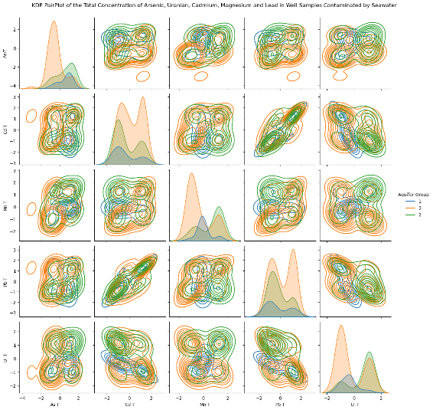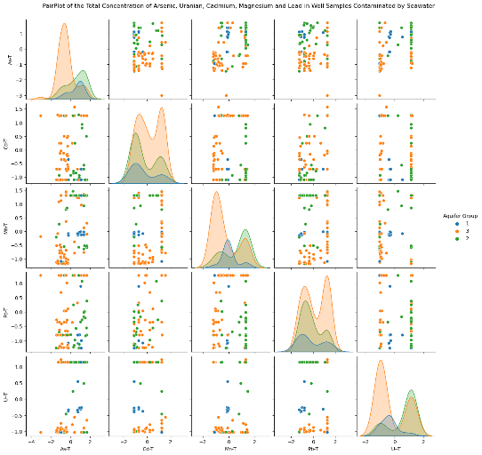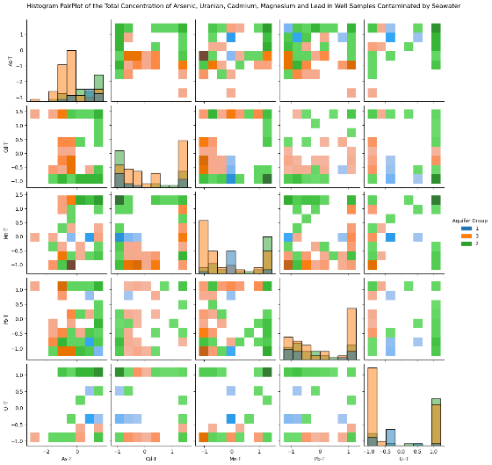
A)
B)
C)

Figure 2: A) From Left to right: A) pairplot, B) hisplot and C) KDE plots of the relationship between metals of interest for SWI dataset where specfic conductance ≥ 1000 or chloride ≥ 150 μg/L.
Figure *** shows the relationship between different Metals with salt water intrusion for each aquifer group. Some of the week correlations between uranium and Lead. it also shows that a lot of the aquifer types are with salt water intrusion are aquifer type 2. Figures in the appendix show expected or undetermined relationships for seawater intrusion variables, temperature and precipitation variables and all other variables (Fig ***,***, *** and *** Appendix)

